**Question – 1 Define a class Complex to represent a complex number. Declare instance member variables to store real and imaginary part of a complex number, also define instance member functions to set values of complex number and print values of complex number.**

**Ans.**

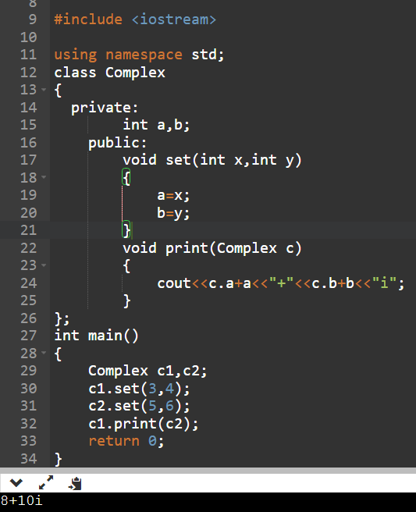

**Question – 2 Define a class Time to represent Time (like 3 hr 45 min 20 sec). Declare appropriate number of instance member variables and also define instance member functions to set values for time and display values of time.**

**Ans.**

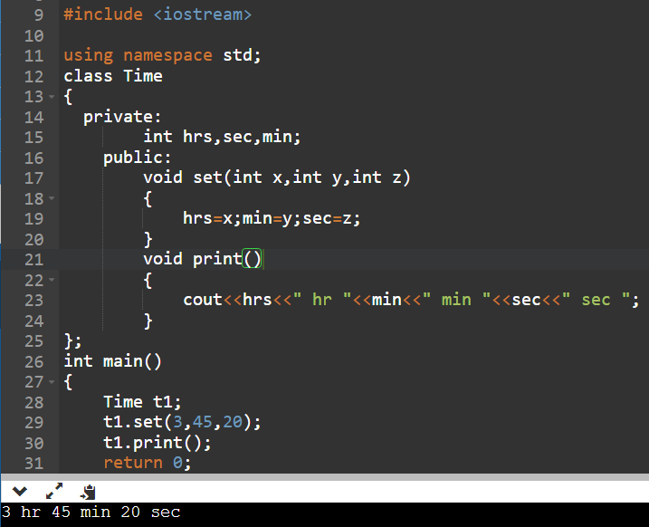

**Question – 3 Define a class Factorial and define an instance member function to find the Factorial of a number using class.**

**Ans.**

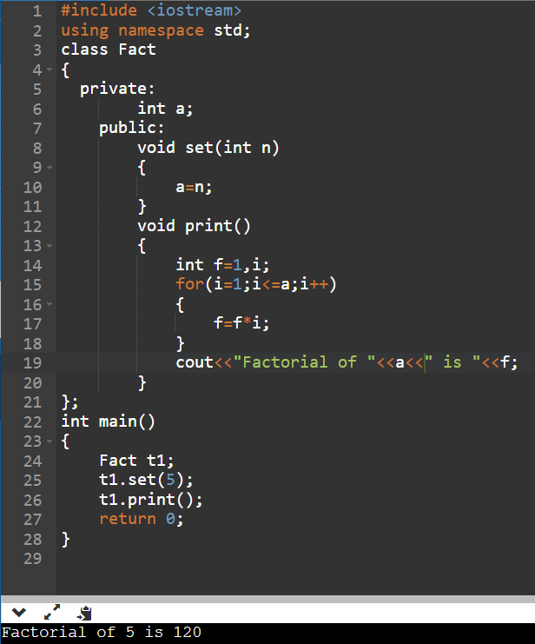

**Question – 4 Define a class Largest Number and define an instance member function to find the Largest of three Numbers using the class.**

**Ans.**

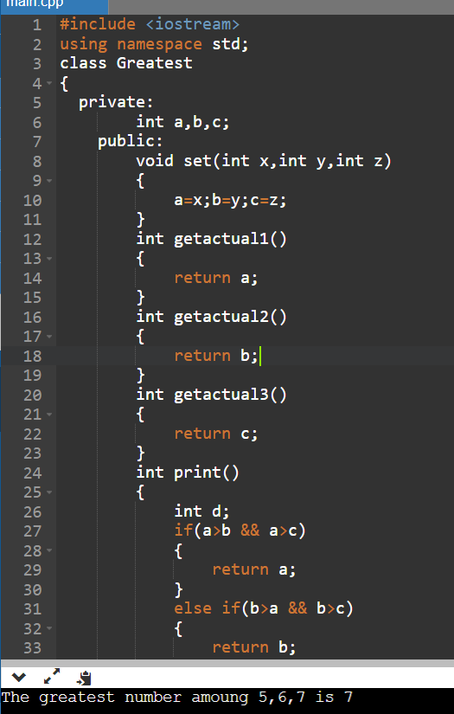

**Question – 5 Define a class ReverseNumber and define an instance member function to find Reverse of a Number using class.**

**Ans**

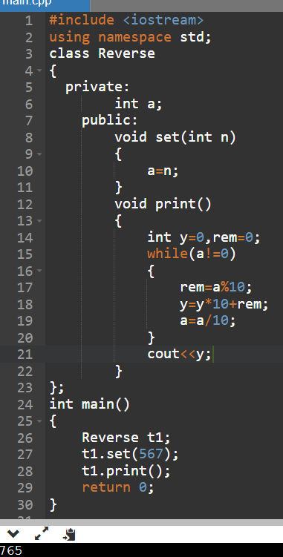

**Question – 6 Define a class Square to find the square of a number and write a C++ program to count number of times a function is called.**

**Ans.**

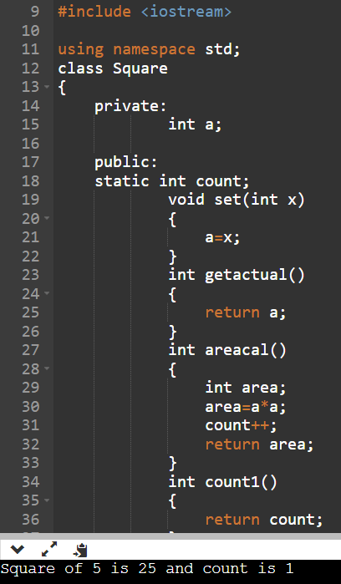

**Question – 7 Define a class Greatest and define instance member function to find Largest among 3 numbers using classes.**

**Ans.**



**Question – 8 Define a class Rectangle and define an instance member function to find the area of the rectangle.**

**Ans.**

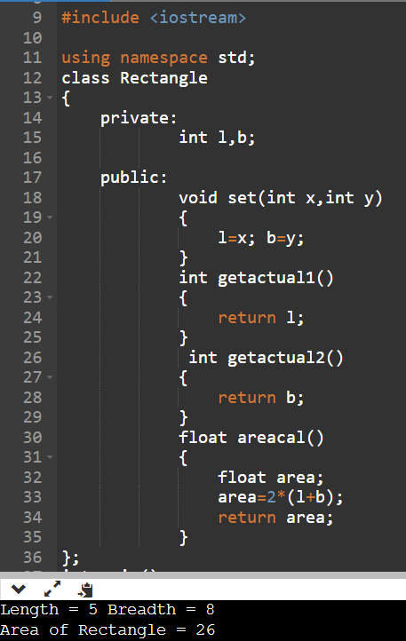

**Question – 9 Define a class Circle and define an instance member function to find the area of the circle.**

**Ans.**

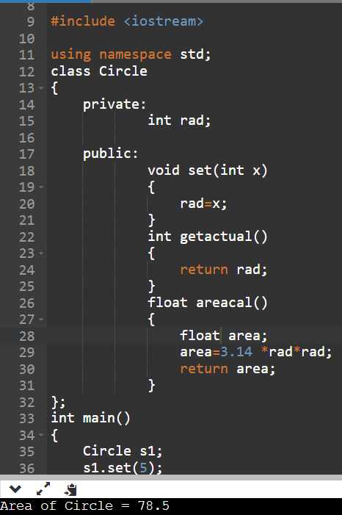

**Question – 10 Define a class Area and define instance member functions to find the area of the different shapes like square, rectangle , circle etc.**

**Ans.**

